Chapter 11
AI Based Autonomous Voice Enabled Robot with Real Time Object Detection and Collision Avoidance using Arduino
Dr. Suvarna Pawar¹, Dr. Pravin Futane², Dr. Nilesh Uke³, Sourav Patil^{4*}, Riya Shah⁵, Harshi Shah⁶, Om Jain⁷

¹ Associate Professor, Dept. of Information Technology Engineering, Vishwakarma Institute of Information Technology, Pune-411048 (M.H.), India. Email Id: suvarna.pawar@viit.ac.in.
² Head of Department, Dept. of Information Technology Engineering, Vishwakarma Institute of Information Technology, Pune-411048 (M.H.), India. Email Id: pravin.futane@viit.ac.in.
³ Principal, Trinity Academy of Engineering, Pune-411048 (M.H.), India.
⁴ ⁵ ⁶ ⁷ Third Year Students, Dept. of Information Technology Engineering, Vishwakarma Institute of Information Technology, Pune-411048 (M.H.), India. *Corresponding Author Email Id: sourav.22020060@viit.ac.in.
Abstract: With a busy schedule and never-ending work meetings, we need a small helping hand for us to do a few household chores like switching on/off lights, detecting and bringing an object be it fruit or something else. Our project introduces artificial intelligence-based voice, a remotely operated robot Currently, there are a variety of methods for controlling one. Controlling it with voice commands is the most user-friendly option. It is also a well-known reality that handicapped persons suffer a variety of physical mobility challenges. In such circumstances, the robot operations are to be Controlled by human voice instructions, it may be a viable solution to the problem. Controlling the robot using the user's vocal commands and visual feeds which will be helpful to make it easier and more precise for the robot to operate Voice-controlled robots powered by artificial intelligence (AI) assist people save time and effort in their daily duties. Following the interpretation of voice instructions, a set of control data for completing a job is created. The machine can perform different movements forward, backwards, turns, start/stop and night mode operation.
Keywords: Artificial Intelligence, IOT, Python, OpenCV, Image Processing, Deep Learning, AI in Military.
- Introduction
Our goal is to create a robot vehicle that can be operated easily and effectively using a person's or user's voice instructions [12]. These systems are sometimes referred to as Speech Controlled Automation Systems (SCAS) (SCAS). The robot we created is a prototype of the technology described above. The concept behind is to build a robot that is controlled via human voice instruction commands. The robot will be operated remotely using an Android application called Smart AI on a smartphone. For remotely automating the robot, Android applications provide a very effective interface. It has a number of functions that might be beneficial to the robot's user.

For the needed purpose, an android application with numerous functions is employed in this design. Bluetooth Technology facilitates the communication between the application and the robot. The provided commands will be sent across the channel and received by the bluetooth module. The goal of voice controlled robotic vehicles [VCRV] is to listen to the user's orders and respond appropriately. The system will require accent training in which the device will begin to grasp the instructions supplied and the commands will be integrated to the arduino software in order to do duties appropriately.

The basic goal of creating a VCRV is to analyze voice and behave in accordance with pre-programmed directions. Backward, forward, right, left, night mode, and halt the robot are the most fundamental commands. The car will be operated wirelessly by a smartphone running an Android application. Our goal is to create a robotic vehicle using advanced smartphone technology in a very simple and cost-effective manner, with object detection using the ESP32 webcam module to understand the difference between various categories of objects and act accordingly. We will also be using an ultrasonic sensor for object detection and avoiding the robot colliding with the object by passing parameters to the robot's program.

Natural language processing is a new technology that allows us to command and control objects using our voices. Wireless technology has become more important in the current day. Wired networks are clumsy, perplexing, and difficult to understand. These wireless technologies have had a significant positive influence on human existence, and the rate of human progress has accelerated significantly. Voice instructions are used to control the voice control robot, which are supplied directly to the robot by the user. This is a wireless robot, as far as we can tell. The android app is loaded on a smartphone that serves as a transmitter. The android application issues the commands. The Arduino is recognized via Bluetooth connection and the programme Smart AI.

The Arduino is linked to a Bluetooth module (HC-05). Because Arduino is programmable, it must be programmed in C or C++. As a result, connecting an Android application (Smart AI) and a Bluetooth module over Bluetooth is simple. The user gives the orders to the Smart AI Android App. The voice recognition technology is utilized in a variety of applications to operate devices and aid in the modernization of society. The main concept for this model is an Android smartphone that will be used to interact with a robot via Bluetooth network connectivity. This technology is used to aid persons with impairments, as well as in industrial applications such as voice-controlled working robots. Each technology has its own set of advantages and disadvantages. Bluetooth-based voice-controlled robot systems, on the other hand, have the upper hand. Devices can be linked at a distance of up to 10 meters. In addition, Bluetooth uses the 2.4GHz ISM band, which is available worldwide. Bluetooth services can be accessed at a speed of up to 2.8 Mbps. As a result of these advantages, fast progress in Bluetooth-based voice recognition systems has been possible.
Vehicles are currently operated manually, and the driver is responsible for everything. Human effort is required for every action, including starting and halting, applying brakes, shifting gears, and accelerating. However, in recent years, new technologies have emerged that might be combined with regular automobiles to produce new vehicles. In the modern era, the advent of gesture concepts is bringing the real and digital worlds closer together. For all dangerous activities, we prefer technology over people. Although these robots were originally controlled by hand, they may now be controlled via voice and gestures. Gesture and voice recognition technology may be defined as the interaction between a computer and human body language. This creates a channel of communication between humans and machines. The purpose of this research is to make robots more secure while also simplifying their control systems. To manage verbal directions, a smart cell phone is needed. The execution evaluation is completed using the findings of the underlying investigations. The anticipated gains might be applied in a variety of situations, including businesses, medical clinics, and environmental laboratories. The most serious issue in the world is the provision of human labour. With the use of this device, they may move around in a wheelchair on their own by just uttering commands through Bluetooth. To construct a prototype, all of the features are merged into a single module.
- Literature Survey
To improve the functionality of AI Robot, Licheng Jiao et al. [1]. In this paper it is specified about the types of detection models, datasets, In a nutshell, metrics and applications. Domain-specific image object detectors may be classified into two groups, according to their research: one is a two-stage detector, the most typical of which is Faster R-CNN, and the other is a one-stage detector, such as YOLO or SSD. In the field of generic object detection, significant progress has been accomplished thanks to the improvement of DL and the ongoing increase of processing capabilities. R-CNN, the first CNN-based object detector, made a number of key advancements to the field of generic object identification. To assist newbies, get started in this sector, they've provided many common object detection designs. Deep learning models like CNN, RNN, and LSTM may be used to detect objects. OpenCV and other computer vision libraries are also free to use. Furthermore, huge data is the cornerstone of the Internet of Things. Deep learning's performance is dependent on a large amount of data, which acts as rocket fuel.

Humayun Rashid et al. [2] stated that the robot's motions can be controlled by sending vocal instructions to the microcontroller, which are then translated to text using an Android smartphone application, because the design system includes a microcontroller connected to the smart phone using Bluetooth module for the transmission and reception of voice instructions. Following the data are the robot's responses, which are given in reaction to the verbal commands. Voice commands are used to make a precise movement in a certain direction. The robot's speech technology is based on a pre-recorded human voice on an SD card. The robot's speech system then uses this audio file. The robot will say the sentences and act according to the instructions after getting each of the directives from the device.

In this paper, by Soniya Zope et al. [3] According to the project's description, voice commands for controlling robotic equipment or vehicles, as well as manual remote operation control, are included. To integrate the control unit interface and detect signals sent by the android app, the ATMEGA32 microcontroller and bluetooth device are employed. The Android app sends the serial data received from the bluetooth module linked to the ATMEGA32. The research explains how to control robot cars using a Wi-Fi module and an Android app on a smartphone.

In the given paper, by V. Shivaraju et al. [4] We'll go through how we'll use a Wi-Fi module to operate a robot-controlled automobile using an android application on an Android device. We'll also illustrate how, in the absence of an Android phone, we can operate the appliances by sending regular text messages to the user. The benefit of employing a robot-controlled automobile is that it may be utilized for a variety of applications. This concept might simply be extended to incorporate a spy camera that can transmit movies to the user through Wi-Fi. Solar cells would be used instead of the standard lithium-ion battery for the project. This robot car may also be used to easily transport things from one location to another. Better Wi-Fi connectivity will be added to this project, allowing them to communicate across vast distances.

Lokireddy Sai Siddhardha Reddy et al. [5] stated in the paper, the main premise of a robotic vehicle is to evaluate voice orders and do the work without the presence of a person in the vicinity. The robot is controlled by the user's voice. An android-developed application that communicates through Bluetooth modules is required to operate the robot using user voice input instructions. As a result, this publication caters mostly to persons who are physically challenged. As a result, individuals will be able to drive their self-car with more safety and increased security in the future aspect, as automated braking or slowing features will protect them from unexpected attempts at abrupt hit-and-run situations. In terms of hardware, a modified Arduino will be used to operate the robotic vehicle's motors. Ultrasonic sensors will also work with the Arduino board to assist in performing the autonomous braking of the car when it detects any unexpected or sudden obstruction.

Santoshachandra Rao Karanam et al. [6] given in the paper, the way Image processing is vital in sectors such as Medical imaging, medical image analysis and processing, web mining, and so on are all examples of image mining. CBMIR (Content-Based Medical Image Retrieval) technologies are crucial in the healthcare industry. The primary function of medical databases images is to facilitate the rapid search and retrieval of medical data. The following article explains how to use deep learning algorithms in picture processing for image segmentation. The numerous deep learning applications for medical imaging and image mining are discussed in this article. It also shows you how to employ content-based image retrieval and discover flaws in medical images.

M. Naveen Kumar et al. [7] stated in paper, the purpose of image processing is to help a computer understand the information in a picture. OpenCV is a computer library that is mostly used to process images. It is frequently used as the de facto API in computer vision applications. Image processing software can help us solve a variety of real-time problems. This article includes step-by-step instructions as well as examples of real-time image processing applications utilising OpenCV.

Mingyuan Xin et al. [8] mentioned in their paper based on an evaluation of the error backpropagation approach, we suggest a unique depth neural network training criterion for maximum interval minimal classification error. The cross entropy and M3 CE are analyzed and combined at the same time to enhance results. Finally, we put our proposed M3 CE-CEc to the test on two deep learning benchmark datasets, MNIST and CIFAR-10. The results of the studies show that M3 CE can boost cross-entropy and can be employed in addition to the cross-entropy criterion. In both datasets, M3 CE-CEc performed admirably.

Prof. P Y Kumbhar et al. [9] stated to use the Haar Classifier on the Raspberry Pi BCM2835 CPU processor, which is a mix of SoC and GPU based architecture, to conduct real-time Face identification and tracking of the head postures position from high quality video. For face detection and tracking the location of head positions, the libraries SimpleCV and OpenCV are utilized. The SimpleCV and OpenCV framework libraries, as well as the above-mentioned hardware, were used to generate results at 30 frames per second at 1080p resolutions for enhanced precision and speed in face detection and tracking the movement of the head.

Wenhuan Wu et al. [10] mentioned that, in an autonomous face recognition system, face detection is crucial. This paper discusses how to detect faces using a cascade of Adaboost classifiers and how to set up OpenCV in MCVS. We were able to detect faces with the help of OpenCV. A detailed study of the face detection findings is also provided. The approach utilized in this article has a high accuracy rate and outstanding real-time performance, according to experiments.
- Proposed System Design and Methodology
1. Architecture Diagram:

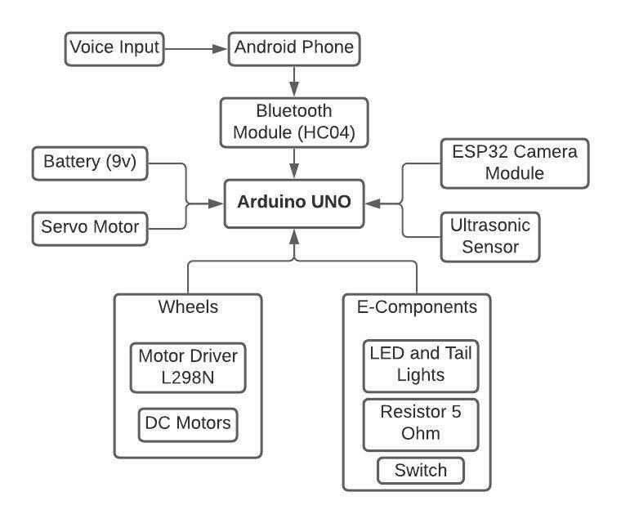

Fig.1: Block Diagram of Robot
The flow to architecture starts with giving input to the robot with the help of android phone, afterwards user has to connect their device with the Bluetooth Module, later on the Arduino is connected to with the sensors and devices like Camera Module, Servo Motor, Ultrasonic Sensor and Battery, then various other components are connected with the robot to make it more futurized and make all operations flexibly and smoothly like Motor Driver, DC Motors, LED’s, Resistors and Switch. This was all about the Architecture Diagram. The robot functions in a proper way to give better functional requirements to the user of the robot respectively as per their voice commands.

Speech is the fastest mode of communication, according to research, and it has a wide range of uses, including in-car systems, Medical attention, Military personnel, Educate yourself, Intelligent structures. The current approach focuses solely on controlling the robot, which is capable of comprehending orders and carrying them out. The robotic car responds to commands sent through an Android device, which is why Arduino is included in the system. Any Android-based smartphone can be used as the controlling device. The transmitter makes use of an Android application that is necessary for data transmission. These commands are read by the receiving end, which then interprets them to operate the robotic vehicle. The android device provides orders to the car to travel forward, backward, right, and left. Arduino uses the commands to control the motors, which let the car move in four directions. Serial communication data is transmitted between the android smartphone and the receiver. The Arduino software is intended to control the motor through a motor driver circuit in response to orders provided from an Android device.

2. Flow Chart:
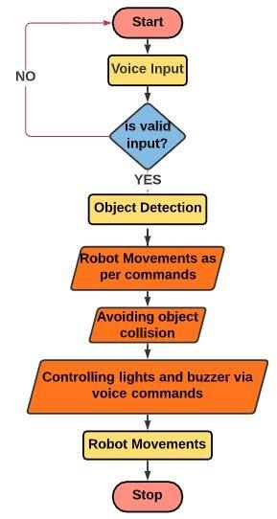
Fig.2: Project Flow Chart of Robot
User needs to give voice input, if the input is valid the signal process further and detects objects then the robot moves as per command and avoids object collision. It also controls light and buzzer as per commands of the user and at last stops. Here the user has to firstly switch on the robotic car then the bluetooth module will start by blinking the red light present inside it and afterwards the user will connect the bluetooth module with the android application with HC05 bluetooth connection where the bluetooth connection having a range of 10 meters, then the user will click on the voice option present in the android application and will give voice commands which are already feeded into the arduino UNO board once the commands of user matches with the command present in the arduino code the operation will be performed and once the user will use commands as “Go Ahead” then the UR sensor will check the object in forward direction if it detects any inside 1 meter range then it will not move and play the buzzer twice and turn on the red parking lights inside the robot otherwise move in forward direction upto 8 seconds asper delay given into the arduino code, same as for “Left” command the robot will check for object in left direction and will perform accordingly, same will be for “Right” and “Go Back” Command and lastly the “Night Mode” command, this command will turn on the white lights present inside the robot to get clear vision for the camera to detect objects and display the names when used in night time.

This was the process flow of the autonomous vehicle with all functionality and processes carried out to perform various operations by the user of the robot.

3. System Requirements:
The following components make up the System Design: -

- Arduino UNO Board
- Motor Driver L298N
- HC05 Bluetooth Module
- Ultrasonic Sensor
- BO Motors
- Connecting Wires
- ESP32 Camera Module
- Power Supply
- Wheels
- Servo Motor
- USB to TTL Module
- Smart AI for Arduino (Android Phone Application)
a. Arduino UNO:
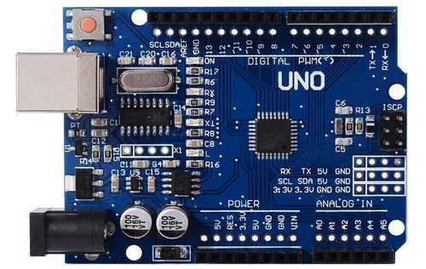

Fig.3: Board for Arduino UNO R3

The Arduino Uno [18], a microcontroller board, uses the ATmega328P CPU. There are 14 digital I/O pins, six analogue inputs, a 16 MHz ceramic resonator, a USB port, a power connector, an ICSP header, and a reset button on this board. The Arduino Board comes with everything you'll need to get started.

- L298N Motor Driver:
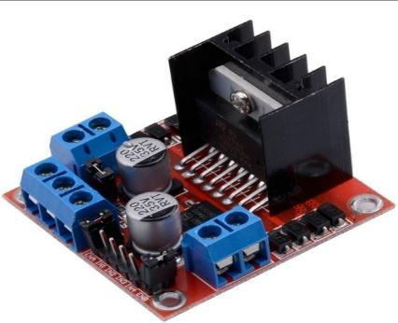

Fig.4: Motor Driver L298N

The L298N is a dual-channel H-Bridge motor driver that can drive two DC motors seamlessly.

- Bluetooth Module HC05:
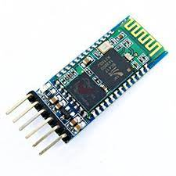
Fig.5: Bluetooth Module (HC05)

The HC-05 is a Bluetooth module with a 2.4GHz frequency that allows two devices to communicate wirelessly. The HC-05 Bluetooth Module is a simple Bluetooth SPP (Serial Port Protocol) module that allows you to create a wireless serial link that is transparent. It connects to a controller or a computer through serial communication, making it simple to connect.

- Ultrasonic Sensor:
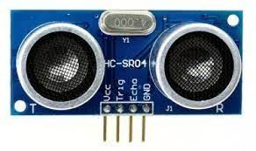
Fig.6: Ultrasonic Sensor HC-SR04

An ultrasonic sensor is a device that generates ultrasonic sound waves to count the distance to a target item, translates the reflected sound into an electrical signal, and replies. The sensor monitors the time between the transmitter's sound emission and its contact with the receiver in order to compute the distance between the sensor and the item.

- BO Motors:
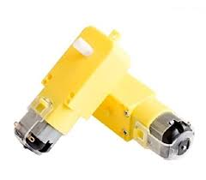
Fig.7: Battery Operated Motors

DC/BO Motor (Battery Operated) is a small DC geared motor that produces a lot of torque and rpm at low voltages. When powered by a single Li-Ion cell, this motor can spin at around 200 rpm in clockwise as well as in anti-clockwise direction.

- Connecting Wires:
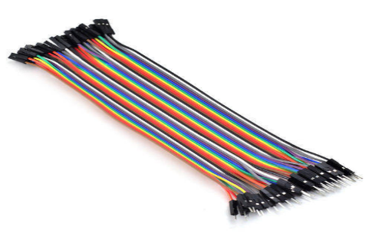
Fig.8: Connecting Wires (Jumper Wires)

Jumper wires are simple cables with connector pins on each end that may be used to link two locations without soldering. They come in a variety of configurations, including male-to-male, male-to-female, and female-to-female. Individual jump wires are connected by slipping their "end connectors" into slots on a breadboard, a circuit board's header connector, or a piece of test equipment. Solid Tips, Crocodile Clips, Banana Connections, RF Connectors, and other types of connectors are available.

- ESP32 Camera Module:
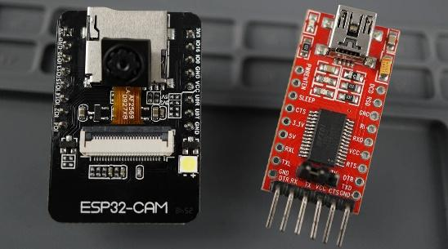

Fig.9: ESP32 Camera Module

The ESP32-CAM module is a full-featured microcontroller with video camera streaming and a microSD card connection built in.

- Power Supply:


Fig.10: 9v Power Supply

Used to provide electricity to the Arduino so that it may conduct tasks. Batteries are made up of one or more cells, each of which produces an electron flow in a circuit through chemical processes. An anode (the '-' side), a cathode (the '+' side), and some form of electrolyte are the three fundamental components of all batteries (a substance that chemically reacts with the anode and cathode).

- Wheels:
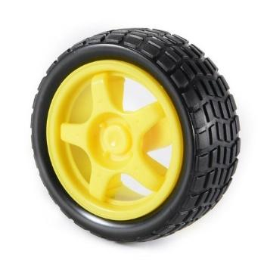

Fig.11: Robot Wheels

Used to rotate or move robot from one place to another smoothly. With circular black grip to hold the robot stable in every road condition.

- Servo Motor:
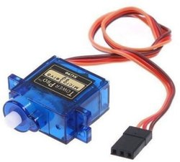

Fig.12: Servo Motor SG90

A servomotor is a rotary or linear actuator that can regulate angular or linear position, velocity, and acceleration with extreme precision. It is made up of an appropriate motor and a position feedback sensor.

- USB to TTL Module:
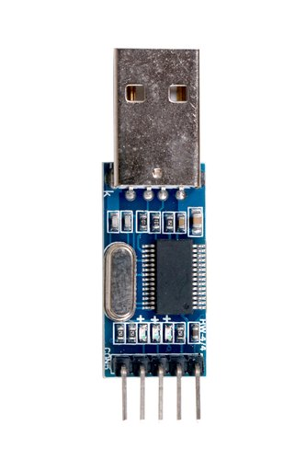

Fig.13: USB to TTL Module

USB to TTL module converters are a must-have for prototyping since they allow for direct communication with the target device. This module plugs onto your computer's USB port and has four cables that connect to your target device. This PL2303HX USB to TTL converter module is required for basic serial connection with non-USB devices.

- Smart AI for Arduino (Android Phone Application):
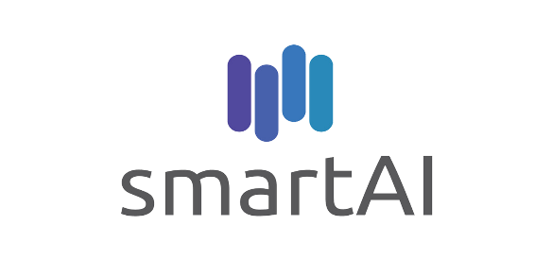
Fig.14: Android Application

Android Application Smart AI to control the robot through the voice commands and perform various operations on the autonomous robot.

  - Project Methodology:

One of the most essential elements that can help spread the use of robots in everyday life is human-robot interaction. One of the potentials uses for orienting visitors or tourists is guidance systems (e.g., at museums, tourist navigation in cities, etc.). We utilized a simple method to control a robotic automobile using human voice. To begin, Google's voice to text converter is used to convert all human directions to text, which is then compared to the code currently being sent into the arduino board. Everything is contained within the Android app that we are utilising. The textual format directive is then delivered to the Bluetooth module of the robot. The goal of this study is to provide a simplified robot hardware architecture with strong computing platforms so that robot designers may concentrate on their research and testing rather than Bluetooth connectivity infrastructure. Since students may construct their own robots for a minimal cost and utilize them as a platform for experiments in a variety of courses.

    - Voice Controlled System:
Speech recognition is concerned with transforming speech to digital data, whereas voice recognition is concerned with identifying the speaker. Voice recognition works by analyzing how people's speech differs from one another. Everyone has a distinct speech pattern that is impacted by both physiology (mouth and throat size and shape) and habits (voice pitch, speaking style, accent, and so on).

In some aspects, voice recognition software varies from speech recognition software. Voice recognition technology is most commonly used to authenticate a speaker's identification or to ascertain the identity of an unfamiliar speaker. The two forms of speech recognition are speaker verification and speaker identification.

  - Algorithm:

Paul Viola and Michael Jones suggested an effective object identification approach based on Haar feature-based cascade classifiers in their 2001 work "Rapid Object Detection with a Boosted Cascade of Simple Features." It's a machine-learning approach in which a cascade function is learned from a large number of positive and negative pictures. It's then used to find objects in additional photos.

We'll be working on facial recognition in this room. To train the classifier, the method necessitates a large number of positive (face-containing) and negative pictures (images without faces). We'll have to extract properties from it after that. This is accomplished by employing the haar attributes depicted in the picture below. They look a lot like our convolutional kernel. The total number of pixels in the white and black rectangles is subtracted from the total number of pixels in the white and black rectangles to provide a single value for each feature.

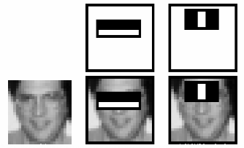
Fig.15: Haar Cascade Working with Face Detection
- Robot Implementation
- Libraries Used:
A reservoir of pre-trained Haar cascades is kept in the OpenCV library. The majority of Haar cascades are employed for one of the following purposes:
- Face detection
- Eye detection
- Mouth detection
- Full/partial body detection
- Object Detection
- Adafruit Motor Shield library
- Servo Motor Library

- Android Application Design:
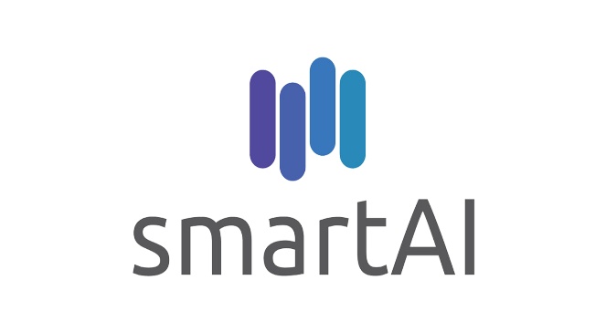

Fig.16: Android App Logo
Logo of the Android Application Smart AI, which is developed in Android Studio to control the AI based autonomous vehicle through voice commands by App and for surveillance through camera module.

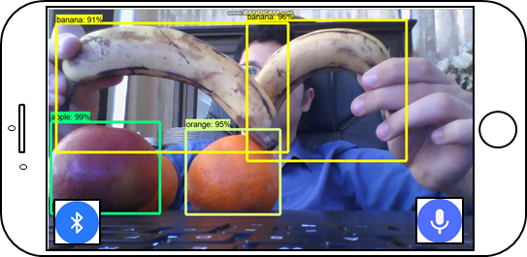
Fig.17: Android Application Design ESP32 Cam detecting the objects as per shape, color and size.

- Development Software:

Arduino IDE is used to develop the program for Arduino UNO Board to control all things and perform accordingly as per the given input.
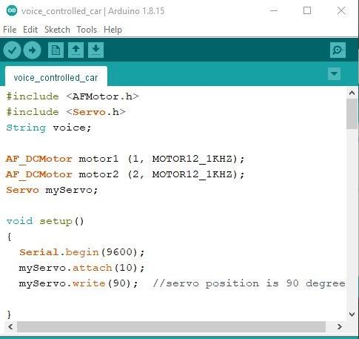
Fig.18: Arduino IDE for Development of Hardware Code

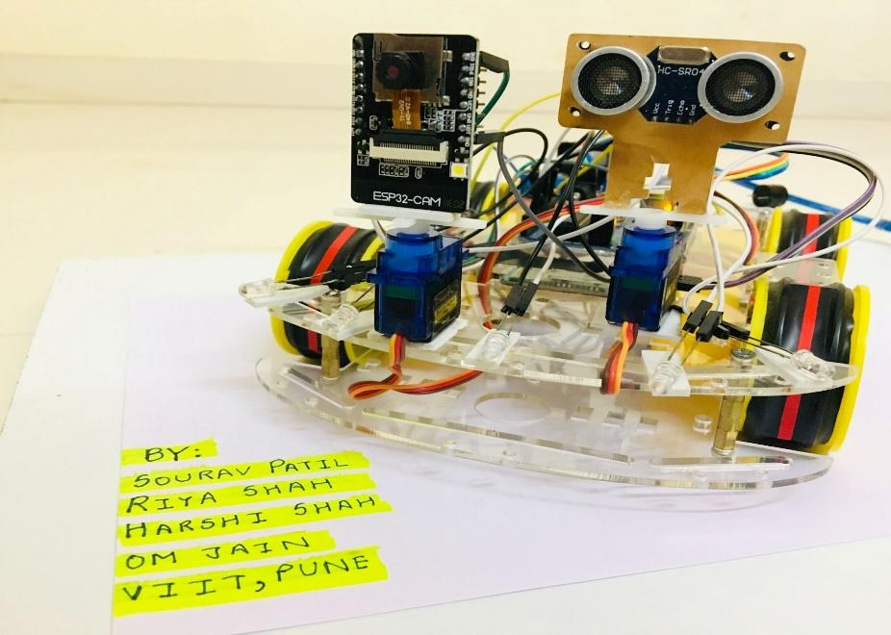
- Hardware Implementation:
Fig.19: Implemented Hardware with UR Sensor and Camera Module for Object Detection and Avoidance.
- The above diagram works as follows:

- The Bluetooth Button is used to search for available bluetooth connections and connect to Bluetooth Module HC-04.

- The Mic button is used to take voice instructions and perform robot operations based on those inputs by translating the commands to text using Google Voice Assistant's Speech-to-Text API [7], with the robot doing the actions as programmed in the arduino uno board.

- The background is the video streaming by the robot in front of it detecting and telling the difference between various objects using the ESP32 camera module [8].

- The App can also detect other objects like, laptop, keyboard, human, watch, mouse, and many more and display it on the app screen by streaming through the camera module.
  - Results and Discussion
When the robot receives a spoken command or instruction from the user, it begins to move.

- The user's commands can be used in a variety of ways. "Go Ahead", "Back", "Left", "Right", “Stop” and “Night Mode”.

- The robot follows the user's orders/commands and performs the tasks assigned to it.

- When an obstruction appears in front of the robot at a distance of less than 1 meter, the Ultrasonic sensor detects the impediment and the robot promptly stops by sounding the buzzer twice.

- The robot will remain in this mode until the user issues the next vocal instruction.

- The Robot operates on Bluetooth Technology with a range of 10 meters which enables it to be controlled from long distances as well.
- The robot also detects the objects around it and displays name of the component in the user’s android application Smart AI through video surveillance via ESP32 Camera module.

The robot is given the following vocal commands:

TABLE 1

INPUT (User Voice Commands) | OUTPUT (Execution of commands by robot)
“Go Ahead” | Robot goes in Forward Direction
“Back” | Robot executes reverse and go back
“Left” | The Robot Moves to the Left
“Right” | The Robot Rotates to the Right
“Stop” | Terminates all previous commands then turn red light and buzzer on and stops
“Night Mode” or “Night Mode Off” | Starts the Front White Lights as Headlights

Bluetooth Connectivity:

When it comes to technology and communication, wireless connectivity is quickly displacing conventional connections. Designed to be used instead of cable connections, the HC-05 communicates with the electronics through serial communication. It's often used to send files via a short-range wireless connection between small devices like mobile phones. It works at a 2.45GHz frequency. Within a 10-meter range, the data transfer rate can range from 1Mbps to 10Mbps. The HC-05 module may function with a 4-6V power supply. Baud rates of 9600, 19200, 38400, 57600, and others are supported. It's also possible to utilize it in Master-Slave mode, which means it won't broadcast or receive data from other sources.
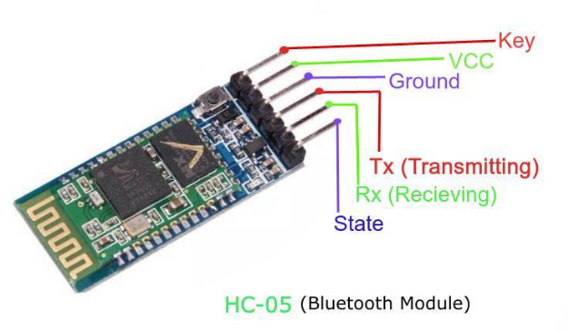

Fig.20: Bluetooth Module HC05 Pins Functionality

Case1: When the distance between you and the barrier is more than or equal to 1 metre, you have a few options for the use of voice commands "Forward," "Backward," "Left," "Right," "Stop," and so on.

Case2: When the distance between you and the barrier is smaller than 1 metre, you have a few options for voice commands. “Backward”, “Left”, “Right”, “Stop”.
  - Conclusion and Discussion
This research outlines the prototype and design for an android robot; nevertheless, much more work and research is needed in the future to turn the created robot into a fully working consumer product. The built Robot may move in any direction based on a verbal command received from the user using an Android phone and Bluetooth. The robot can be moved forward, backward, left, and right via voice instructions. Thanks to an ultrasonic sensor, the Robot can also move completely independently without striking any obstacles.
Using Bluetooth technology, the suggested solution shows how an Android smartphone may be used as a remote controller for robots and other embedded equipment. The suggested technique also demonstrates how image processing may be used to assist any disabled person with little tasks, as well as guide and recognize items.
  - Future Scope
The Advantages of voice-controlled Robots eliminate the need for human intervention and allow for speedier operation execution. The robot has the ability to comprehend natural language orders. Following the interpretation of the spoken commands, a set of control data is created for tasks such as object identification and collision avoidance. We discover techniques to outsource human activities to machines through robotics, and we can help or even replace humans in doing tasks. Although currently restricted to a few voice commands, we hope to enhance this utilising Machine Learning and Natural Language Processing in the future and also, we will be using the Lora wan Protocol in our robot by which it can also work in extreme low bandwidth areas. Because, as the robot contains a camera module that will show live streaming, we may utilize this system for military purposes by integrating appropriate sensors. We can allocate IP addresses to this system in the future so that more than one device can be linked, which will aid with live broadcasting of the suspicious actions of the Enemies and also by training it with various images to understand the difference between the Indian Army and other unregistered people.
  - Acknowledgement
We would like to convey and express our deepest gratitude and appreciation to our guide, Dr. Suvarna Pawar ma’am, for giving us her invaluable guidance, support and encouragement on a regular basis to integrate constantly on our project and helped to get better day by day, which inspired us to work even harder to complete the project and we are also thankful for her efforts which she tooked on us to make this project happen.
References
[1] Licheng Jiao, Fan Zhang, Fang Liu, Shuyuan Yang, Lingling Li, Zhixi Feng, Rong Qu, “A Survey of Deep Learning-Based Object Detection”. ISSN: 2169-3536, Volume 7, 2019.

[2] Humayun Rashid, Iftekhar Uddin Ahmed, Sayed Bin Osman, Qader Newaz, Md. Rasheduzzaman, S M Taslim Reza, “Design and Implementation of a Voice Controlled Robot with Human Interaction Ability”. ISBN: 978-984-34-2030-5, Paper ID: 65, 26-27 January, 2017.

[3] Soniya Zope, Preeti Muluk, Rupali Mohite, Aishwarya Lanke, Megha Bamankar, “Voice Control Robot Using Android Application”. ISSN: 2454-1362, Volume-3, Issue-2, 2017.

[4] V. Shivaraju, V. Karthik Kumar, “Robot Controlled Car using Wi-Fi Module”. ISSN: 2319-8885, Volume-06, Issue: 04, February-2017, Pages: 0759-0762.

[5] Lokireddy Sai Siddhardha Reddy, M Sumanth, Maram Venkata Nagasai Teja Bavigadda Purushotham Naidu, Shalini Tiwari, “Voice Based Robotic Vehicle with Obstacle Avoidance”. ISSN No. 0976-5697, Volume 11, Special Issue I, May 2020.

[6] Santoshachandra Rao Karanam, Y. Srinivas, M. Vamshi Krishna, “Study on image processing using deep learning techniques''. ISSN No. 2214-7853, October 2020.

[7] M. Naveen Kumar, A. Vadivel, “OpenCV for Computer Vision Applications”. March 20, 2015.

[8] Mingyuan Xin, Yong Wang, “Research on image classification model based on deep convolutional neural networks”. 11 February 2019.

[9] Prof. P Y Kumbhar, Mohammad Attaullah, Shubham Dhere, Shivkumar Hipparagi, “Real Time Face Detection and Tracking Using OpenCV”. E-ISSN: 2349-7610, VOLUME-4, ISSUE-4, APR-2017.

[10] Wenhuan Wu, Yingjun Zhao, Yongfei Che, “Research and Implementation of Face Detection Based on OpenCV”. Vols. 971-973 (2014) pp 1710-1713, 2014-06-25.

[11] Aditya Chaudhry, Manas Batra, Prakhar Gupta, Sahil Lamba, Suyash Gupta, “Arduino Based Voice Controlled Robot”. ISBN: 978-1-7281-4826-7/19/$31.00.

[12] Shivangi Nagdewani, Ashika Jain, ”A Review On Methods For Speech-To-Text And Text-To-Speech Conversion”. ISSN: 2395-0072, Volume: 07, Issue: 05, May 2020.

[13] Dr.G.Rohini, Monikandan. R, Ramesh. R, Vignesh. K, “Spy Bot for Monitoring Human Activities In Restricted Area During Covid19 Lockdown”. ISSN- 2394-5125, VOL 7, ISSUE 05, 2020.

[14] Dr. C. Shyamala, S.RahmathNisha, B. Aswini, V. Bakkiya Sri, S. Dheyvanai, ”Online Voice Based Multipurpose Surveillance Robot for Defence Using Artificial Intelligence” Vol.12 No.7(2021), 784-794.

[15] Dinesh P Mital, Goh Wee Leng, “A Voice-Activated Robot with Artificial Intelligence”. ISBN:0-87942-688-8, CH2976-9/91/0000-0904.

[16] Yasir Ali Memon, Imaaduddin Motan, Muhammad Ali Akbar, “Speech Recognition System For A Voice Controlled Robot With Real Time Obstacle Detection And Avoidance”. Volume-4, Issue-9, Sep.-2016.

[17] P. Ramya, U. Rehanabegum, P. Manimegalai, Dr. S. Manikandan, “Voice Controlled Robot Writer for Physically Challenged”. Volume 1, Issue - 3, Dec 2017.

[18] Sumeet Sachdeva, Joel Macwana, Chintan Patela, Nishant Doshia, “Voice-Controlled Autonomous Vehicle Using IoT''. 21 November 2019.

[19] Aditya Chaudhry, Manas Batra, Prakhar Gupta, Sahil Lamba, Suyash Gupta, “Arduino Based Voice Controlled Robot”. 1 October 2019.

[20] Vikash Sharma, Vrutik Parvadiya, Rohan Naik, “Automate Voice Controlled Robot Using Raspberry Pi 3b+”. Vol 8, No 1 (2021).

[21] Mamatha K R , Shalini Ragothaman ,Krithika Raj D , Susmi Zacharia , Anusha N, “Implementation Of Voice Controlled Robot Using Android Application”. ISSN: 2454-5031.

[22] K. Manu Subhash, Dr. M. C. Chinnaaiah, I.S.B.N. Varma, G. Abhiram Varma, “Robot control through voice recognition using LabVIEW”. ISSN: 2454-132X, Volume 6, Issue 3.

[23] N. U. Alka, A. A. Salihu, Y. S. Haruna and I. A. Dalyop, “A Voice Controlled Pick and Place Robotic Arm Vehicle Using Android Application”. e-ISSN: 2320-0847, p-ISSN: 2320-0936, Volume-6, Issue-7, pp-207-215.

[24] Adarsh Singh, Omkar Naik, Amit Ghadi, Ahmed Khalil, “Voice Control Robotic Arm as A Physical Assistant For Paralyzed Person”. ISSN: 2349-5162, Volume 8, Issue 12, December 2021.

[25] Lochan Basyal, Sandeep Kaushal, Gurjeet Singh, “Voice Recognition Robot with Real Time Surveillance and Automation”. ISSN: 2320-2882, Volume 6, Issue 1, March 2018.

[26]https://how2electronics.com/esp32-cam-based-object-detection- identification-with-opencv/

[27]https://lastminuteengineers.com/l298n-dc-stepper-driver-arduino-tutorial/

[28]https://robu.in/product-category/motors/bo-motors/

[29]https://dronebotworkshop.com/esp32-cam-intro/

[30]https://www.researchgate.net/publication/346391164_Study_on_image_processing_using_deep_learning_techniques

[31]https://www.researchgate.net/publication/301590571_OpenCV_for_Computer_Vision_Applications

[32]https://jivp-eurasipjournals.springeropen.com/articles/10.1186/s13640-019-0417-8

[33]https://www.scientific.net/AMR.971-973.1710

[34]https://www.academia.edu/Documents/in/Image_Processing_with_OpenCV

[35]https://create.arduino.cc/projecthub/ashraf_minhaj/speech-controlled-robot-247039

